Tandoori Chicken Kebabb
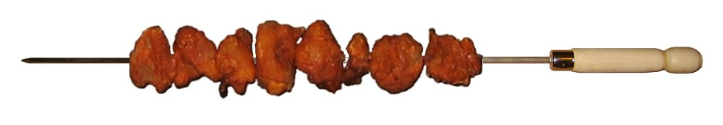
I regularly travel to different places and camp with my friends & family. And our favorite dish is the mouth watering chicken “barbecued” over red-hot charcoal. Though for some, it might seem to be a difficult task to light up the charcoal and barbecue (BBQ) the chicken... I wish to enumerate some simple steps to get you going with a jiffy.

All that you may require
Fuel & Tools
- Charcoal = 1 kg (this is the wood coal used in most Indian Restaurants)
- Kerosine/ Paraffin = 200 ml (to light up coal. Don't use Petrol/highly inflammable stuff)
- Steel Pipe = to blow at the coal (say 1 inch in diameter & 18 inches of length)
- BBQ Rods = 2 (available in any utensils stores)
Raw materials
- Fresh Chicken = 750 gms (to serves 3 people, cut in medium size)
- ChickenTandoor Masala= 50 gms (I use SRR brand, tastes real good)
- Ginger & Garlic Paste = 1 Table spoon (leveled)
- Thick Curd/ Yogurt = 2 Table spoon (heaped)
- Lime = 1 (juiced)
- Chilly & Salt = to taste (if needed)
OPTIONAL (for garnishing)
- Black Pepper Powder = ½ teaspoon
- Mint = few leaves
- Onion =1 sliced
- Lime = 1-2 (cut in half)

5 easy steps to Light the Charcoal

- Take 3 large stones and arrange it to construct a make-shift stove on the ground keeping the level in mind to place the BBQ rods. I have made my own stove by bending a thick metallic sheet for my convenience.
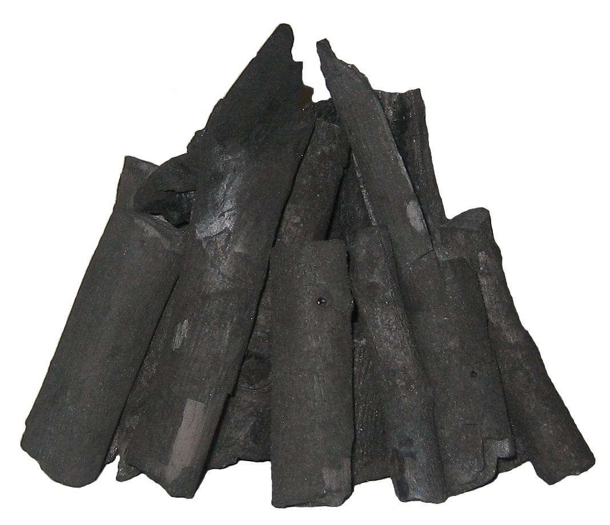
- At the center of your stove place few thin & long pieces of charcoal and arrange these pieces to form a conical shape (as shown in the image). This will ensure faster lighting up of the charcoal.
- Now pour, say 10-20 ml of Kerosine in the center of the coal and light it up with the help of a matchbox. If the fire subsides, put more Kerosine and reignite. Repeat this until the coal has turned red-hot and is of the size of your fist.
- Use the steel pipe to blow air smoothly & regularly at the center of hot coal. With in a few minutes you will see the fire spreading and the coal burning by it self and probably see & hear the coal crackling.
- Finally, make sure the charcoal is evenly spread and lit up covering the area where you will be placing your BBQ rods loaded with chicken pieces.

Tandoorifying the Chicken

- Mix all the stuff as mentioned in items 5 to 10 and marinate the chicken well in advance for at least 4 hrs in the refrigerator (but not in the freezer). While traveling make sure you store the chicken in an ice pack.
- Once ready with burning coal, pierce the BBQ rod in to 5-6 chicken pieces in an orderly fashion and place it at least 2-3 inches above the red-hot coal (with no flames and no freshly added Kerosine to the coal).
- The moment the bottom edges of the chicken pieces darken, rotate the rods on to the opposite side. Repeat until the chicken is fully cooked. Keep in mind, over cooking may burn the chicken and render it dry. Once done squeeze lime and add a little pepper powder. Serve hot along with garnishing.

Remember, only experience will make you a better chef. I am sure, every body along with you would like to be a part of the tandoori process. In-fact all my camping friends are now great tandoori-chefs.

Bibin Mathews
Moderator- blog.marshal.net

Safety & Disclaimer:
- Do not keep combustible materials close-by while working with fire. Avoid synthetic clothing. Keep safe distance from the fire. Keep children away.
- This is an external activity and do not exercise the above inside any enclosure/ house/ tent. Always have a person with good experience to guide.
- Do not attempt the above under the influence of alcohol or drugs. Keep fire extinguisher as standby. Get prerequisite permission form local authorities.
- This article is not a guide and is only the opinion of the author alone. The author of this article, blog.marshal.net, marshal.net and their owners or their siblings, representatives, take no responsibility in an event of any kind of accidents/ conditions/ reactions caused for any reasons what so ever.
- You are advised to use commercially available professional material and equipments with high safety standards with proper certification.

